In My Opinion …
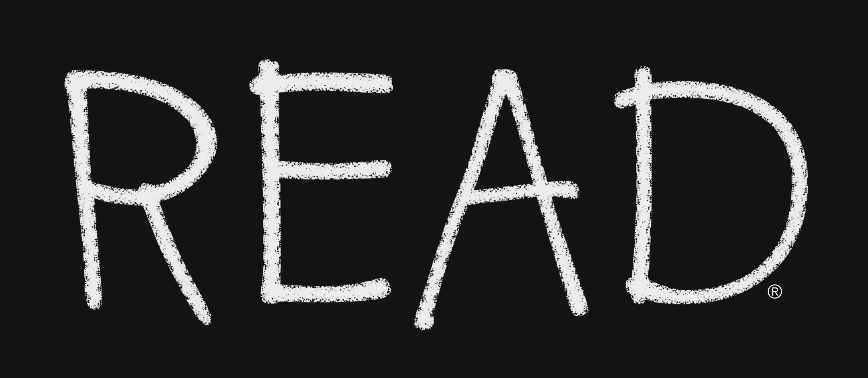

The Book Thief by Markus Zusak. Winner of the Michael L. Printz Award for Young Adults (as well as the National Jewish Book Award and making the list of Publishers Weekly Best Books of the Year), this book was published in Australia (the author’s home country) as an adult title, so it would be a shame to allow the label of “young adult to deter those past the teenage years from reading it. Our narrator is Death, but this isn’t the humorless, scythe-wielding character of Death we’ve come to know (but perhaps not so much love). Death tells us a story set in World War II Germany of a girl named Liesel Meminger. Liesel has lost her family and come to live with Rosa and Hans Hubermann on the ironically named Himmel (Heaven) Street (for while this street provides Liesel with safe haven, by the end of the book heaven truly has turned into hell). Though she is nine, Liesel cannot read, but her new foster father begins to change that, aided by Liesel’s penchant for swiping books from the library of the town’s mayor’s wife. With her growing reading ability, Liesel is able to provide comfort to others during dangerous times, including a young Jew hiding in her basement. Death in his narration is quite the word smith. As The Washington Post states in its review, “Death, like Liesel, has a way with words. And he recognizes them not only for the good they can do, but for the evil as well. What would Hitler have been, after all, without words? As this book reminds us, what would any of us be?”

Zusak, Markus. The Book Thief. New York: Alfred A. Knopf, 2006. (J F Z967b)

Eric A. Kidwell
Professor/ Director of the Library

