In My Opinion …
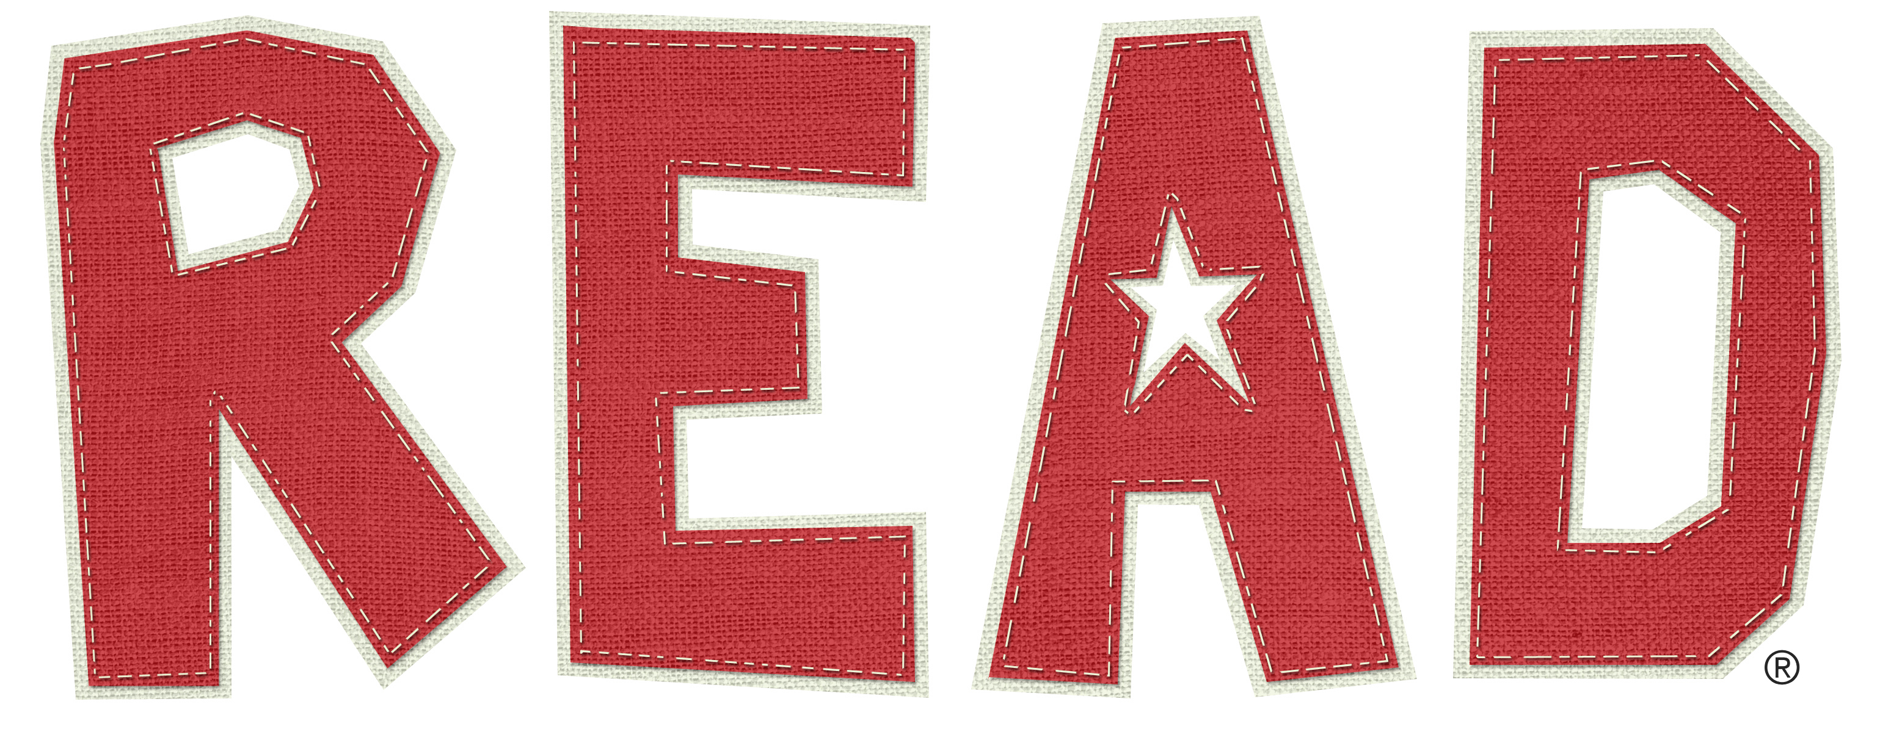

Promised Land: Thirteen Books that Changed America by Jay Parini: Parini is a professor at Middlebury College in Vermont and a noted poet, author and literary critic. Here he has selected the thirteen books he considers as most influential in our nation’s development and proceeds to make a very compelling case for each of his selections. It is quite a diverse and inclusive list that Mr. Parini offers (and the book does include a list of an additional 100 influential titles in an appendix). What are the thirteen?

Uncle Tom’s Cabin , The Autobiography of Benjamin Franklin, The Feminine Mystique, The Federalist Papers, Walden, Of Plymouth Plantation, How to Win Friends and Influence People, The Journals of Lewis and Clark, The Soul of Black Folk, The Adventures of Huckleberry Finn, On the Road, The Promised Land, and The Common Sense Book of Baby and Child Care.

Publishers Weekly gave Parini a starred review for his effort and stated that his book “ … ought to be on the syllabus of American studies courses.”

Parini, Jay. Promised Land: Thirteen Books That Changed America. New York: Doubleday, 2008. (810.935873 P231p 2008)

Eric A. Kidwell
Professor/ Director of the Library

